TITLE OF THE PAPER
Name SURNAME*, Name SURNAME**
*Faculty, Department, University, University address
**Faculty, Department, University, University address
author_1 e-mail, author_2 e-mail

Key words: writting, word editor

- INTRODUCTION
To write an article for publishing in conference proceedings use Microsoft Word for Windows (from Microsoft Office 2007 or later). The paper should be prepared in two forms. The first - two page (one sheet) abstract - will be included to conference proceedings. The second - with no page limit - will be published in .pdf format. To publish full text paper in Acta Mechanica et Automatica the official English language is necessary.
Page numbering: Arial Narrow 9 pts., page margins.
Hyphenation: automatic (Fig. 1).
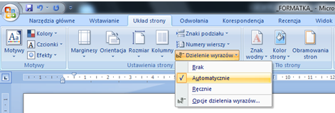
Fig. 1. Hyphenation - automatic
Odd Page Header: 9-th International Symposium . . . – Arial Narrow 8 pts., italic, underlined, right-aligned, single spacing: before 0 pts., after 12 pts..
Even Page Header: Author_1name, Author_2 name, Title of article – Arial Narrow 8 pts., italic, underlined, left-aligned, single spacing: before 0 pts., after 12 pts.
Titles of chapters: Arial Narrow 10 pts., bold, single spacing: before 18 pts., after 18 pts.
Guidelines for the introduction and abstract:
- title of the article: Arial Narrow 12 pts. bold, single spacing: before 48 pts., after 0 pts.;
- names of authors: Arial Narrow 10 pts. bold, single spacing: before 18 pts., after 18 pts.;
- chair, department, university, university address: Arial Narrow 9 pts. sigle spacing: before 0 pts., after 0 pts.;
- authors’ e-mail addresses: Arial Narrow 9 pts. underlined, single spacing: before 12 pts., after 12 pts.
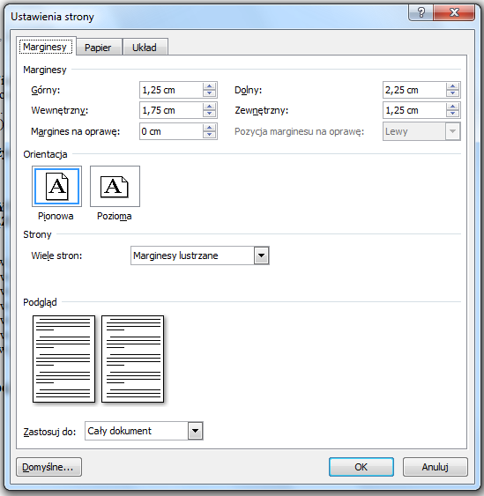
Fig. 2. Page set-up – margins
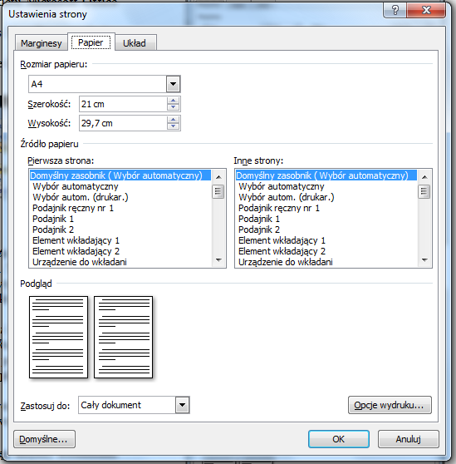
Fig. 3. Page set-up – paper
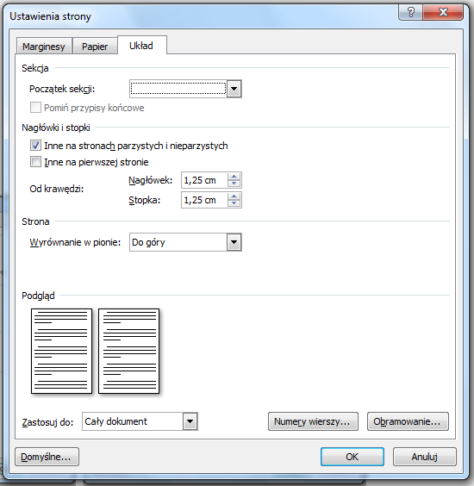
Fig. 4. Page set-up – layout
With the exception of introduction and abstract, the whole document should be prepared in two-column format:
- format – A4 (21 x 29.7 cm);
- column width – 8.5 cm; spacing between columns – 1 cm (single spacing);
- font: Arial Narrow – 10 pts., normal;
- article text style – standard;
- alignment – two-sided;
- paragraph format – the first line of 0.5 cm;
- for binding – 0 cm;
- mirror margins: internal – 1.75 cm, outer – 1.25 cm, upper – 1.25 cm, bottom – 2.25 cm;
- header – 1.25 cm;
- footer – 1.25 cm.
General settings are given in Figs. 2 – 4.
- CHAPTER TITLE
A file containing the document shall be sent by electronically to: wm.kmiis@pb.edu.pl.
  - Section title
Numbering styles more complex than the XX should be avoided. The titles of sections should be in Arial Narrow
10 pts., bold, single spacing: before 18 pts., after 18 pts.
  - Drawings, diagrams, graphs, tables
Drawings, diagrams and tables should be clear, made of black lines on a white background, centered in the column. When placing drawings in colour, please note that they are in colour only on the web site of the journal, whereas the printout will be in black and white. Drawings, diagrams and graphs shall be denoted as Fig. X.
Width of the figure should not exceed the width of a column (8.5 cm), spacing: before 18 pts., after 0 pts. In case of broader drawings, it is advisable to place them by closing the division into columns in a given place (Fig. 6).
The text should include references to figures and tables (e.g., "... in Fig. 1," "... in Tab. 1"). All descriptions in the drawing area should be typed with the font of not more than 9 pts.
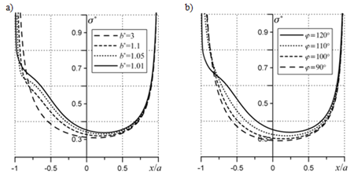
Fig. 5. Contact pressure distribution: a) gap distance effect;
b) gap orientation effect
Drawing captions should be typed in Arial Narrow 9 pts., single spacing: before 3 pts., after 18 pts. When using one description to several drawings, the drawings shall be denoted in the sequence: a), b), etc. Letters a), b) should be within the figure), with the description as shown in Fig. 5.
Tab. 1. Table name
tekst | tekst | tekst | tekst
tekst | tekst | tekst | tekst
tekst | tekst | tekst | tekst
tekst | tekst | tekst | tekst
Tables and figures should be placed in portrait orientation. The thickness of lines in tables should be ½ point. For tables larger than the column act as in the case of extensive drawings.
Text in the table should be in Arial Narrow – 9 pts., single pacing: before 1 point, after 1 point (in special cases it is possible to use a smaller font without reducing the readability of the table).
Captions above the tables should be done in Arial Narrow 9 pts., single spacing: before 18 pts., after 3 pts. In the text directly under the table, use the line spacing above 18 pts.
  - Mathematical formulas
Mathematical formulas should be type written in mathematical style, aligned to left and numbered irrespective of chapter numbering.
Fonts used in formulas:
- mathematical symbols (e.g. sin, lg) – Cambrai Math 9 pts., straight;
- variables – Cambria Math 9 poits, italic;
- indices (lower/upper) variables (e.g. ij in σ_{ij}) – italic font 8 pts.;
- indices (lower/upper) constants (after original names, e.g. 1 in σ₁) – straight font 8 pts.;
- indices (lower/upper) dependent constants and variables as above, font 6 pts.;
- vectors and matrices – straight, bold font 10 pts.;
- intervals: before 6 pts., after 6 pts., single spacing

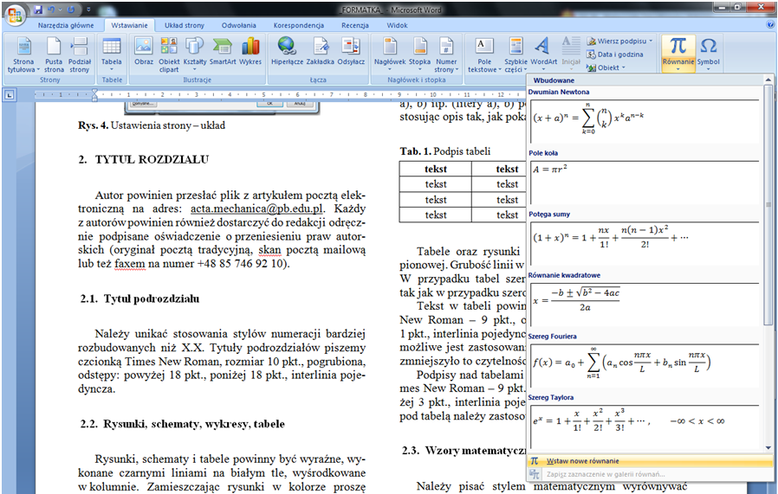
Fig. 6. Inserting formulas

Numbers of formulas typed in standard text format should be placed in parentheses and aligned to right of the edge of a given column, as below:
${\left(x+a\right)}^{n}=\sum_{k=0}^{n}{\left({n \atop k}\right)x^{k}a^{n-k}}$ (1)
where: $x$ – description, $a$ – description, $a^{n-k}$ – description,
$\left({n \atop k}\right)$– description.
The formulas, both numbered and those in the text should be type written as shown in Fig. 6 (so that they do not increase the line spacing).
SI units must be consistently applied in the text.
REFERENCES
- Abedrabbo N., Pourboghrat F., Carsley J. (2006), Forming of AA5182-O and AA5754-O at elevated temperatures using coupled thermo-mechanical finite element models, Internatio-nal Journal of Plasticity, 23, 841–875.
- Goshima T., Hanson M.T., Keer L.M. (1990), Three-dimensional analysis of thermal effects on surface crack propagation in rolling contact, Journal of Thermal Stresses, Vol. 13, 237-261.
- Grześ P. (2009), Finite element analysis of disc temperature during braking process, Acta Mechanica et Automatica, Vol. 3, No. 4, 36-42.
- Kaczorek T. (2002), Positive 1D and 2D Systems, Springer Verlag, London.
- Niesłony A., Kurek A., Bański R., Čižek L. (2010), Static and fatigue tests of explosively cladded materials – titanium-steel, Scientific Papers Opole University of Technology, Series Mechanics, 97, 337/2010 (in Polish).
- Pisula J., Płocica M. (2013), Evaluation of the Quality of Meshing for Designed Pair of Bevel Gears with Independent Design System, Mechanik, 2/2013, 138 (in Polish).
- Winter D.A. (1990), Biomechanics and Motor Control of Human Movement, John Wiley & Sons Inc.,Toronto.
List of the literature should be typed in Arial Narrow – 9 pts., alphabetical order.
[...] This theory has also become a base for development of a model by Shlyannikov (1995a, 1995b). [...] In the works of other authors (Jarema, 1977; Kocańda S.and Kocańda A., 1989) [...]
In the list of references, year should be embedded in parentheses after author's name. In the case of several items by the same author published in the same year, the numbers should be supplemented with successive letters of the alphabet.
For the literature appearing in Russian or Ukrainian transliteration should be applied (including names appearing in the text). If there are three or more authors of the same item, only the first one should be mentioned with a note: “et al.” ,e.g. [...] This device has been previously used for the analysis of brittle fracture of elements with triangular notches in the biaxial load conditions. (Seweryn et al., 1997).
Titles: "Literature" and "The title of the article in English," should be in bold Arial Narrow 9 pts. , single spacing: before 18 pts., after 18 pts.
Any acknowledgments and notes should be at the end of the article
(9 pts.) Such as: "The work has been accomplished under the research project No. 7 T07C 006 12 financed by the Scientific Research Committee.

